NEW 2026  SANDWICHES, WRAPS  & TOASTIES | 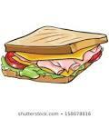  Fresh Sandwich | Toasted    Sandwich | Wrap  Fresh (F)  Toasted (T)
Cheese $2.00
Ham $2.50
Ham & cheese $3.00
Chicken & cheese $4.00
Chicken, cheese, lettuce, tomato & mayo $5.00
Ham, cheese, lettuce, mayo and tomato $5.00
Meatball wrap with cheese, lettuce & tomato $5.00
Egg and Lettuce $4.00



HOT FOOD – Every day
$3.00 Pizza | BBQ Chicken |  | Dim Sims $1.00 each  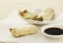  4 for $3.00
$3.00 Pizza | Hawaiian
$3.00 Pizza | Margherita |  |   Daily Special  $5.00
$3.00 Pizza | Pepperoni

DRINKS | QTY | DESSERT | QTY
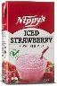  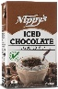  Chocolate milk  S/berry $3.00 |  |   Small dessert  $0.50
  Up and Go  $3.00 |  |   Large Dessert  $2.00
  Water  $1.50 |  |   Berries with  Yoghurt $3.00

SPECIALS - Thursday only |  |  | Quantity
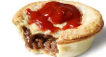 | Pie ** | $4.50
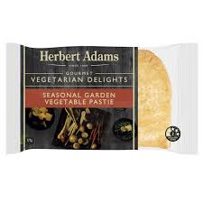 | Pastie ** | $4.50
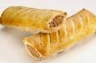 | Sausage Roll ** | $4.50
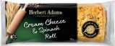 | Cheese & Spinach Roll | $4.50
Special Pie – please circle  VEGAN or Gluten Free |  | $5.00
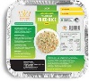 | Fried Rice (Veg) | $4.50

** Halal certified products
TOTAL:

