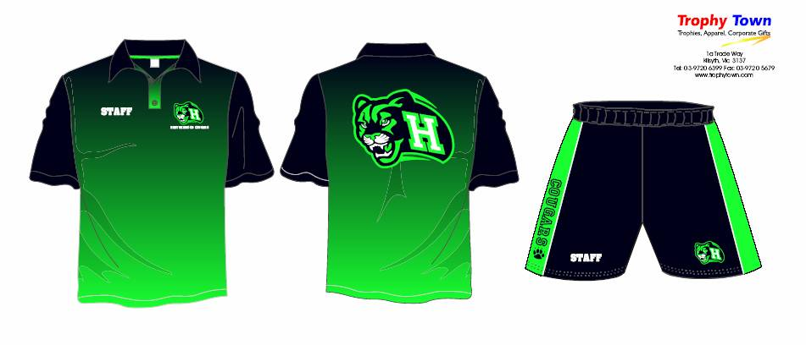
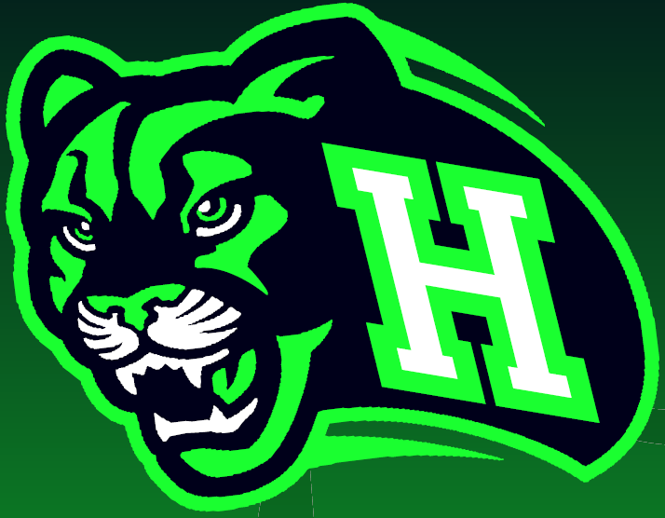


Please note: The sports uniform is optional.

Date: \ \ 20_____

Student’s Full Name _____________________________ Home Group ____________

ITEM | Sizes Available (Please CIRCLE!) |  |  |  |  |  |  | Cost | Quantity | Taken | Order
SHORTS | 10K | 12K | XS | S | M | L | XL | $40
SHORTS | 2XL | 3XL | 4XL | 5XL | 6XL |  |  | $45
S / S POLO | 10K | 12K | XS | S | M | L | XL | $47
S / S POLO | 2XL | 3XL | 4XL | 5XL | 6XL |  |  | $50
SUB TOTAL

ITEM | Sizes Available (Please CIRCLE!) |  |  |  |  |  | Cost | Quantity | Taken | Order
Adult Tracksuit Top | S | M | L | XL | 2XL | 3XL | $50
Adult Tracksuit Pants | S | M | L | XL | 2XL | 3XL | $35
Kids Tracksuit Top | 10K | 12K | 14K |  |  |  | $50
Kids Tracksuit Pants | 10K | 12K | 14K |  |  |  | $35
SUB TOTAL

Tracksuit top and pants, both embroidered with Cougars Logo and Cougars on the back of jacket for $85 total.

Total Price $ _________________
(PAYMENT MUST ACCOMPANY ORDER.)

Prices are subject to change.

Notes: ____________________________________________________________________________________________________________________________________

